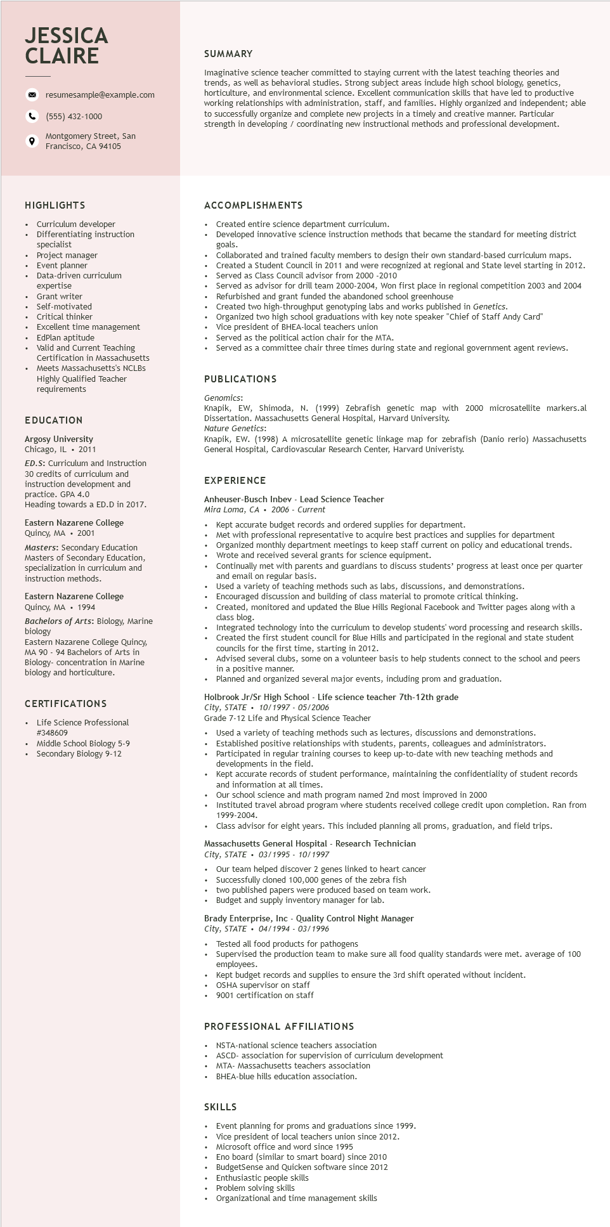
JESSICA CLAIRE
resumesample@example.com
(555) 432-1000
Montgomery Street, San
9
Francisco, CA 94105
SUMMARY
Imaginative science teacher committed to staying current with the latest teaching theories and trends, as well as behavioral studies. Strong subject areas include high school biology, genetics, horticulture, and environmental science. Excellent communication skills that have led to productive working relationships with administration, staff, and families. Highly organized and independent; able to successfully organize and complete new projects in a timely and creative manner. Particular strength in developing / coordinating new instructional methods and professional development.
HIGHLIGHTS
Curriculum developer Differentiating instruction
specialist
Project manager
Event planner
Data-driven curriculum
expertise
Grant writer
Self-motivated
Critical thinker
. Excellent time
management
• EdPlan aptitude Valid and Current Teaching Certification in Massachusetts Meets Massachusetts's NCLBS Highly Qualified Teacher requirements
EDUCATION
Argosy University
Chicago, IL
2011
ED.S: Curriculum and Instruction
30 credits of curriculum and
instruction development and practice. GPA 4.0
Heading towards a ED.D in 2017.
Eastern Nazarene College Quincy, MA 2001
Masters: Secondary Education Masters of Secondary Education, specialization in curriculum and instruction methods.
Eastern Nazarene College Quincy, MA 1994
Bachelors of Arts: Biology, Marine biology
Eastern Nazarene College Quincy, MA 90-94 Bachelors of Arts in Biology- concentration in Marine biology and horticulture.
CERTIFICATIONS
Life Science Professional #348609
• Middle School Biology 5-9
• Secondary Biology 9-12
ACCOMPLISHMENTS
Created entire science department curriculum.
Developed innovative science instruction methods that became the standard for meeting district goals.
Collaborated and trained faculty members to design their own standard-based curriculum maps. Created a Student Council in 2011 and were recognized at regional and State level starting in 2012. Served as Class Council advisor from 2000-2010
Served as advisor for drill team 2000-2004, Won first place in regional competition 2003 and 2004 Refurbished and grant funded the abandoned school greenhouse
Created two high-throughput genotyping labs and works published in Genetics.
Organized two high school graduations with key note speaker "Chief of Staff Andy Card"
Vice president of BHEA-local teachers union
Served as the political action chair for the MTA.
Served as a committee chair three times during state and regional government agent reviews.
PUBLICATIONS
Genomics:
Knapik, EW, Shimoda, N. (1999) Zebrafish genetic map with 2000 microsatellite markers.al Dissertation. Massachusetts General Hospital, Harvard University.
Nature Genetics:
Knapik, EW. (1998) A microsatellite genetic linkage map for zebrafish (Danio rerio) Massachusetts General Hospital, Cardiovascular Research Center, Harvard Univeristy.
EXPERIENCE
Anheuser-Busch Inbev - Lead Science Teacher
Mira Loma, CA 2006 Current
+
Kept accurate budget records and ordered supplies for department.
Met with professional representative to acquire best practices and supplies for department Organized monthly department meetings to keep staff current on policy and educational trends. Wrote and received several grants for science equipment.
Continually met with parents and guardians to discuss students' progress at least once per quarter and email on regular basis.
Used a variety of teaching methods such as labs, discussions, and demonstrations. Encouraged discussion and building of class material to promote critical thinking.
Created, monitored and updated the Blue Hills Regional Facebook and Twitter pages along with a class blog.
Integrated technology into the curriculum to develop students' word processing and research skills. Created the first student council for Blue Hills and participated in the regional and state student councils for the first time, starting in 2012.
Advised several clubs, some on a volunteer basis to help students connect to the school and peers in a positive manner.
na
Planned and organized several major events, including prom and graduation.
Holbrook Jr/Sr High School - Life science teacher 7th-12th grade
City, STATE 10/1997 - 05/2006
Grade 7-12 Life and Physical Science Teacher
Used a variety of teaching methods such as lectures, discussions and demonstrations.
• Established positive relationships with students, parents, colleagues and administrators.
• Participated in regular training courses to keep up-to-date with new teaching methods and developments in the field.
переасси Kept accurate records of student performance, maintaining the confidentiality of student records and information at all times.
Our school science and math program named 2nd most improved in 2000
Instituted travel abroad program where students received college credit upon completion. Ran from 1999-2004.
Class advisor for eight years. This included planning all proms, graduation, and field trips.
Massachusetts General Hospital - Research Technician
City, STATE 03/1995 - 10/1997
.
Our team helped discover 2 genes linked to heart cancer Successfully cloned 100,000 genes of the zebra fish
⚫ two published papers were produced based on team work.
• Budget and supply inventory manager for lab.
Brady Enterprise, Inc - Quality Control Night Manager
City, STATE 04/1994 - 03/1996
Tested all food products for pathogens
Supervised the production team to make sure all food quality standards were met. average of 100 employees.
Kept budget records and supplies to ensure the 3rd shift operated without incident.
OSHA supervisor on staff
9001 certification on staff
PROFESSIONAL AFFILIATIONS
.
NSTA-national science teachers association
ASCD-association for supervision of curriculum development
MTA- Massachusetts teachers association
BHEA-blue hills education association.
SKILLS
Event planning for proms and graduations since 1999.
Vice president of local teachers union since 2012.
Microsoft office and word since 1995
Eno board (similar smart board) since 2010 BudgetSense and Quicken software since 2012 Enthusiastic people skills
Problem solving skills
Organizational and time management skills

